**Turning It In**

Follow the instructions below to create a two page web site.

You will download and extract the *fall.zip* file.  This zip file contains the text and images needed for two web pages, and the starting code for the two HTML files, *fall.html* and *colors.html.*These are all located in the extracted *fall* folder.

When finished, zipthe *fall*folder to *fall.zip* and upload to the D2L dropbox folder named *HTML Hands On Test*.  **Do not leave until the instructor has verified that the uploaded file looks OK.**

File to download and extract:

**Test Format**

This is a open book, open notes exam. The notes you can use include previous projects we have worked on this semester.

This is a **closed neighbor** exam.  This exam must be completed completely by you, without the assistance of anyone else.

You **must use Notepad++** to create your web pages.  You **cannot use Dreamweaver** or any other web authoring tool besides Notepad++.

You **must start with** the supplied *fall.html* and *colors.html* files.

If you have questions about the exam, ask your instructor for guidance (not your neighbors).

**Starting HTML**

**You must start the web site by editing the two supplied HTML files, *fall.html* and *colors.html*.**

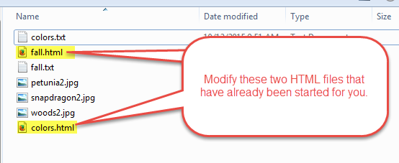

**Requirements**

You will create a two page web site for this hands-on test.  The two pages will have the following names (all lowercase letters) and are already started for you (they are in the ZIP file supplied for this test).

* fall.html
* colors.html

**Most of the requirements are listed in the two figures, below.  Some of the information that did not fit onto the below images are about the photos. The photos have the following names, and your image tag should list the size of each image plus the indicated alt text:**

* **woods2.jpg is 200x127, and should have an alt text of "Woods in the fall".**
* **petunia2.jpg is 200x120, and should have an alt text of "Petunias".**

Also, **include your name in the supplied comment at the top** of each HTML file**.**

**fall.html**

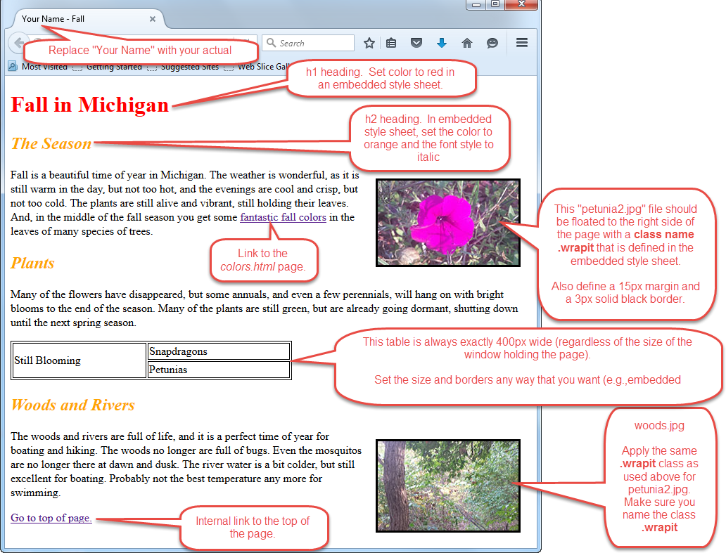

**colors.html**

